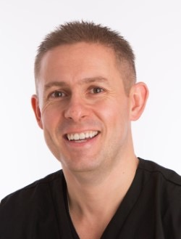 Ross Cutts BDS (Lond) Dip Imp Dent RCS (Eng)

**Digital Implant Dentistry** **– Improving performance and accuracy of our implant treatment sequence.**

Venue – Birmingham Chamber of Commerce, 75 Harborne Road, Edgbaston, Birmingham B15 3DH

Date – May 22nd 2019

Registration 6-00 pm Meeting 6-30 to 8-30 pm.

**Aims:**

* To look at the digital solutions i have added to my practice to improve patient outcomes
* To look at the digital adjuncts for surgical implantology to assist in improving outcomes
* To look at the digital adjuncts for prosthetic implantology to improve outcomes
* To invite discussion at what could be developed in the future to improve patient outcomes

**Objectives:**

* delegates will be able to objectively look at the accuracy of digital processes introduced to the market place
* delegates will have an evidence-based approach to evaluating the digital adjuncts to implant dentistry
* delegates will have an idea of what could be coming to the market place in the future

*Ross graduated from Guy’s Hospital, London in 2000. He is a dentist with Special Interests in Implant Dentistry and Advanced Restorative Procedures.*

*He is a Fellow of the International Team for Implantology (ITI) – and is the Study Club Co-Ordinator for the UK and Ireland and is also a clinical mentor and registered speaker for the ITI.*

*Ross has also been awarded the highly-regarded Diploma in Implant Dentistry from the Royal College of Surgeons, London – one of few to have gained this qualification.*

*He regularly holds implant courses and lectures nationwide and globally on a variety of topics at different levels.*

*As well as being a Fellow of the ITI, he is also a member of the Association of Dental Implantology (ADI) and the Royal College of Surgeons (RCS). His commitment to Cosmetic Dentistry maintains his Full Membership of the British Academy of Cosmetic Dentistry (BACD).*

This Study Club Meeting entitles you to 2 hours CPD.

To attend please contact:

Jack Richardson

The Westbourne Centre, 53 Church Road, Edgbaston, Birmingham B15 3SJ

Tel: 0121 456 0896

Mobile: 07887705663

E-mail: drjrric@hotmail.com